***Rounded End Dummy:***

* Three files were included, namely bee-artificial_v5 v4.stl, .step, and .f3z (a fusion archive file).
* The .stl file can be used for 3d printing the specified dummy.
* Printing instructions:
  + The dummy is printed with flexible materials, namely TPU95 or other more flexible or rigid versions of this thermoplastic material.
  + The dummy should be printed with its body on the build plate for better results.

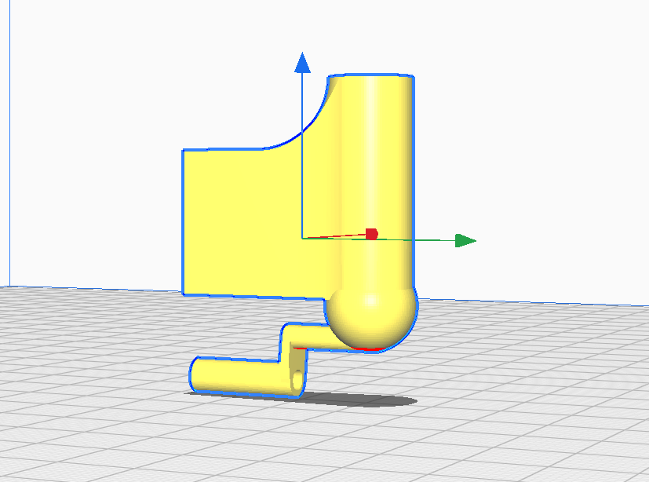

* + Tree support was seen as promising and easily detachable support.

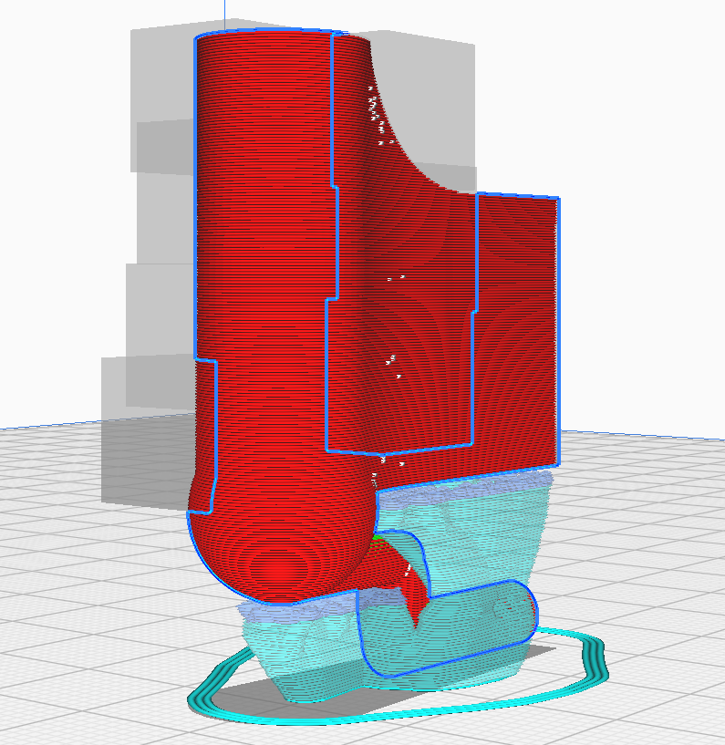

***Flat End Dummy:***

* Three files were included, namely bee-artificial_v6 v1.stl, .step, and .f3z (a fusion archive file).
* The .stl file can be used for 3d printing the specified dummy.
* Printing instructions:
  + The dummy is printed with flexible materials, namely TPU95 or other more flexible or rigid versions of this thermoplastic material.